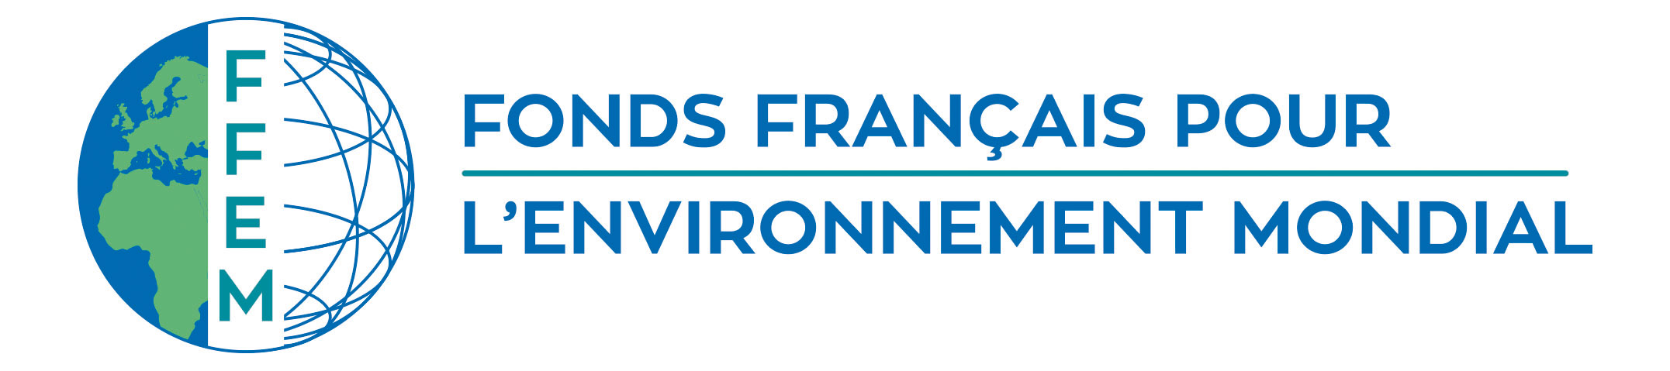
FFEM Selection Committee
Date
Secretariat of the French Facility for Global Environment

The Project Opportunity Note (NOP) must be limited to 10 pages maximum.

Short project description
Country/region
Field of application | Environmentally sound management of chemicals and hazardous waste
Priority topic | Product life cycle, pollution, waste
Cofinancers
Total Project Budget
FFEM contribution
Beneficiary
End beneficiary
Project launch
Project duration
Author

Long project description
COUNTRY

PROJECT ABSTRACT

I.1 Context and issues

I.2 Program objectives

I.3 Program content

I.4 Institutional set-up

I.5 Duration, cost, financing plan

JUSTIFICATION OF the FFEM INVOLVEMENT

Note: it is important to demonstrate the eligibility of the project with regard to the criteria described in the Terms of Reference for the call for project proposals.

